Multilayer tiME synchronization in IoT

CHAPTER 1
Introduction:
IoT (Internet of Things) is a technology that enables every hardware or object to connect and communicate with each other which results in the making network of networks of autonomous devices having fewer computational resources. It also ensures a better quality of services to the users in an unbelievable manner and resolves diverse problems. Devices could be from any group of wireless routers, smarts phones, MiFi devices, embedded sensing and reporting devices, smart motors, etc. Smart metering, smart houses, and tele medicines are a few renowned examples of IoT. IoT is not a solo technology, rather many technologies workcollaboratively andsystematically to provide an interface with the physical world to access, process, and store sensors data appropriately to take decisions accordingly[1].
IoT term was used by Kevin Ashton in 1999 for the first time while working at the Auto-ID center to make a small network of RFID (Radio-frequency Identification) devices. At present, enormous devices are communicating which each other than the total population on earth. According to the Gartner Inc, assessment in 2017, the Internet of Things (IoT) will add20.4 billion operational devices by 2020 [2]with an investment of three trillion dollars.
Many issues and challenges need to be catered to while considering the exponential growth in IoT and the development of allied applications for it. The connectivity of allsort of devices in IoT, their diverse nature, and the huge volume of devices comes into mind. Therefore, a unique methodology is required to be sorted out for IoT implementation. Other big challenges in IoT are the interoperability and compatibility of all multi-purpose devices. These small devices must communicate systematically. Time synchronization is one of the most important parameters for the development of applications in IoT. A variety of several protocols have already been developed for many applications but now a unique protocol for timing synchronization is the requirement. QoS parameters like security, including confidentiality and integrity of data, must be considered prime focus because anyone can access wireless transmission and control devices and alter the information. So, it is crucial to ensure that authentic users get the data and that user information must not be revealed to any unauthorized user in the network. Otherwise, the security of the network will be compromised and the network will be vulnerable to attacks.
The other parameter which needs to be focused on is scalability. As connected devices number is expanding drastically. During the development of routing protocols and the technique for centralized or distributed data storage, scalability must be taken care of. Otherwise, desired functionality cannot be achieved. In IoT, devices are small, have less power consumption, and have the limited computational capability, making energy efficiency an important factor during the development. A designer should also use a sophisticated routing protocol that can help to easily communicate a large number of small devices without congestion or loss of any valuable information. Among all the researchcarried out in all aspects of IoT, time synchronization is a special one because interoperability and updating of events of various devices can be attained through it. By using this, a detailed analysis can be performed after collecting the necessary information. Time synchronization has become a challenging mission for researchers and developers for small devices networks which have less power consumption.
In any wireless or wired network of devices, there are three types of time synchronization frameworks available and these frameworks have theirtime synchronization procedures. These frameworks include Master-Slave, Peer-Peer, and distributed [3]. At the physical layer, the symbol timing synchronization method is used to extract the time offset for synchronization.
CHAPTER 2
Related Work / Literature Review
IoT system-level architecture
IoT architecture can be distributed into three major tiers
Devices Tier
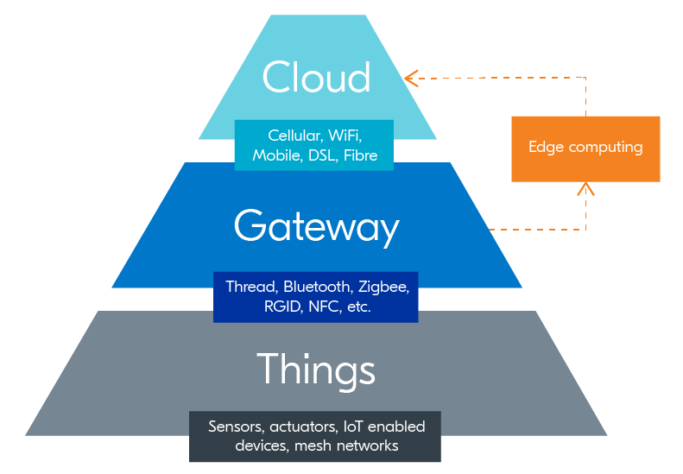
Edge Gateway Tier
Figure ‎2.1 Basic IoT Architecture
Cloud Tie
Devices or things include sensors andactuators. Sensors are responsible for monitoring the environmental change and reportingit accordingly, whereas actuators change and control the mechanism of the system. All these IoT pieces of equipment are connected with the edge gateway using some protocols like Bluetooth, Zigbee, or proprietary protocols (3a a book ).
The edge gateway tier comprises equipmentthataccumulatessensors dataand has the capability of data pre-processing and cloud connectivity securely. A brief comparison of different connectivity of protocols is as under[4]
Protocol | Wifi | Bluetooth | LoRa | Zigbee | Z-Wave | Cellulaire | NFC | 6LowPan
Specification | Based on 802.11n | Bluetooth 4.2 core specification | LoRaWAN | ZigBee 3.0 based on IEEE802.15.4 | Z-Wave Alliance ZAD12837 / ITU-T G.995 | GSM/GPRS/EDGE (2G),UMTS/HSPA(3G), LTE (4G) | ISO/IEC18000-3 | IPv6 over IEEE802.15.4
Network type | LAN,WPAN/P2P | LAN | LAN | LAN | LAN | MAN | P2P | LAN
Topology | Star | Star | Star & Star of Star | Mesh,Star,Tree | Mesh | Mesh | Mesh | Mesh,Star
Power | Low-High | Low | Very Low | Very Low | Very Low | High | Very Low | Very Low
Data Rate | Up to 1.3Gbps | 2.1Gbps | 0.3Gbps to 100 kbps | 250 Gbps | 40 Gbps | Up to 1Gbps | 424 kbps | 200 Gbps
Frequency band | 54 Mb/s | 2.4 G Hz | Various | 868/915 M Hz,2.4 G Hz | 900MHz (ISM) | 850/900,1800/1900/2100 MHz | 13.56 MHz | 2.4 GHz
Modulation Technique | BPSK,QPSK,OFDM,M-QAM | GFSK, CPFSK, 8-DPSK, π/4-DQPSK | GFSK | BPSK,O-QPSK | BFSK,GFSK | GMSK, 8PSK | ASK | O-QPSK o Min LIFS Period
Spread Spectrum | MC-DSSS,CCK,OFDM | FHSS | Chirp | DSSS | DSSS | TDMA, DSSS | FHSS | CSS
Range | Up to 100m | <100m | 3-5km urban area | 10-20m | 30km | Where signal reach | 5cm | 10-20m
Security | WPA and WPA2 | Shared secret | Per-device AES128 keys, AES128 secret  key | CBC-MAC (ext. of CCM) | Data encryption | - | - | SNMP
Cost | Low | Low | Low | good | Effective | Less and vice  versa | Chip | Hight
Risk of data | low collision | High | - | Medium | - | - | - | -
Energy needed | - | High | - | Medium | - | - | - | -
Application | Any device with cellular connectivity | Network for data  exchange headset | Smart city, sensor  networks, industrial automation application | Senor networks Industrial automation | Residential lighting &automation | Use in wifi,ADSL,broadband ,digital TV&Radio | Payment,Transactions,Contextual Information, | Sensor networks,Industrial automation
Network size | Medium | Small | Medium-large | Very large | Large | Very large | Small | Very large

IoT devices producea large volume of data that can be accessed, modified,and updated using cloud computing technology[5]. The cloud partof IoT architecture comprises large database systems which provide storage to sensors data. This tier also controls the communication between all the underlying systems.
Synchronizing an IoT network is quite a difficult task. In most of the cases in IoT, devices used are of low cost and have the less computational capability. These devices can easily go out of sync in the network. As all the devices have their internal clock which leads to making a unified synchronization strategy for implementation to force them to operate in a unified manner. One of the viable methodologies is to make all the devices synchronized from the reference clock. The synchronization of devices’ internal clocks for one time only is not sufficient because the internal clock cannot remain stable for a long period which means after some interval, devices have to get synchronized again. More advanced synchronization methodologies need to be implemented in the network to cater to the drift in synchronization.
The common factors which make the internal clock drift from the reference clock are environmental changes like temperature and pressure as well as internal factors like oscillator aging and battery charge of devices [6]. Temperature variation is an example that disturbs the precision of internal clocks by vigorously altering their frequency and making them stray from the central clock. Time synchronization stability and accuracy can also be affected by many other reasons like the number of devices in the IoT network, and how devices are connected? what sort of messages is being exchanged? software layers with unpredicted delays in communication procedures, or any vulnerability from harmful time originator, etc. Time synchronization can be affected in some practical scenarios in wireless IoT networks which are discussed in [7].
A wide range of IoT applications is being produced and implemented. Due to the diverse nature of IoT, it is very difficult and different as well, to attain time-synchronization in IoT networks. Developer faces a huge difficulty while implementing time-synchronization for a particular application in wireless IoT. At last, they come to the point that a massive study is required before beginning the development of the application. Before resolving the time-synchronization issues, some trade-offs must be taken seriously, because time synchronization is just a variety of processes in IoT applications. Single time synchronization method is not available to maximize all performance parameters and even there is no unique synchronization methodology that can work for all applications. For example, in many situations, to get more exact time synchronization, a lot of messages are required to be exchanged between the network devices which results in the requirement of better, more complex, and high-priced devices [8]. Different methodologies provide a precisesynchronization of time in higher layers, like the application layer [9], as well as a physical layer like Medium Access Control (MAC) layer[10].
Previously, a variety of clock synchronization methods have been discussed because clock value deviates from device to device (D2D) in wireless networks. All such protocols are in contrast to each other significantly due to their constructional parameter, operational parameter, or global objective parameter[11]. For making the wireless network synchronized, it is very essential to achieve the same goal of time by understanding that end nodes or devices clocks are susceptible to drift due to numerous causes including the time requirements for each application changes according to need, and the application variesdepending upon each scenario like single-node vs multi nodes in IoT framework, internal vs exterior synchronization of the clock, fixed vs moving devices, immunity against the fault, structure, sleep scheduling, power consumption. The requirement of synchronization of clock procedure is changed because of the inadequate availability of resources ineachconnecting device, computational capability, the purpose to exchange of information, or the environmental constraints. To make a suitablealgorithm for timing synchronization, some parameters must be identified like the source which originates and broadcasts the clock, at what time the clock information is shared, what procedure is followed bythe upper layer to calculate clock time from the under-laying clock source, or whether the synchronization of the clock is probabilistic or deterministic, from any apprehensions. Because of the difficulty and goalsin selecting the synchronization procedure for every scenario, it is very essential to selecta unique methodology for the synchronization of time.
Application Layer Time Synchronization Methods
Application Layer Time synchronization protocol in a wired network
Network Time Protocol(NTP)
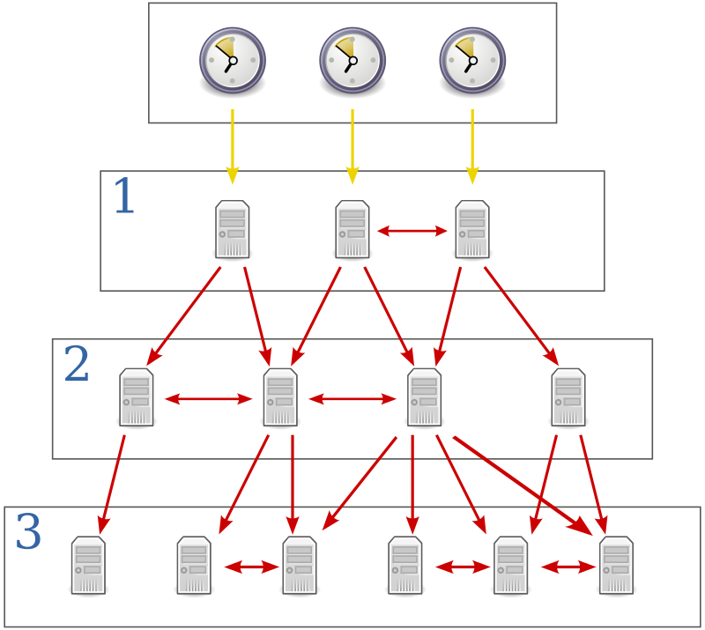
The most extensively used time synchronization protocol is Network TimeProtocol (NTP) which was designed by David L. Mills in 1981. It’s an establishedInternet Standard protocol and this protocol is described in terms of the client-server model. NTP works on the UDP/IP layer of the packet-switched network with a bidirectional message transfer. Thearchitecture of this protocol provides a reliable and secure time synchronization functionality over the internet. NTP enables time synchronization up to tens of milliseconds over the internet and 100 microseconds in the local area network
Figure ‎2.2 NTP working Hierarchy
Simple Network Time Protocol
Another protocol is Simple Network Time Protocol (SNTP) which is derived from NTP without the complex mathematical, statistical methods and clock adjustment techniques that are normally used in the full protocol. SNTP is used where reliability is less important and a better choice for clients having fewer resources.
Wireless sensor Network
Because of the importance ofsensors data synchronization, there have been numerousstudiesonthe synchronization of wireless sensor networks (WSN). There are three major methods
The timing-sync protocol for sensor networks (TPSN)
Reference broadcast synchronization (RBS)
The flooding time synchronization protocol (FTSP)
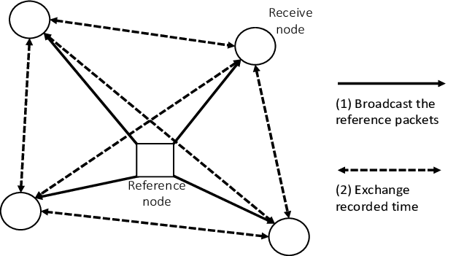
The TPSN creates a network hierarchy in which synchronization messages are sent one level at a time. To synchronize, RBS employs a reference broadcast and local receiver node/device communication.
Figure ‎2.3 TPSN Structure
FTSP uses media access control (MAC) layer timestamping of a synchronization message and linear regression to reduce the effects of non-deterministic transmit errors in WSNs.
Based on features, synchronization protocols can be divided intothe following three categories: technical features, structural features, and global objective features. There are different strategies to achieve time synchronization. One is hardware strategy which uses additional hardware elements to enhance extra features of the network to expand a few constraints, like, to produce the approach much more precise or stable. For example, in [12] a state-of-the-art wireless edge node is suggested to analyze hierarchy in a synchronized way. Researchers used the Global Positioning System in [13]and multiple connected devices get synchronization through real-time clock (RTC) hardware [14]. Whereas, software technique centers its focuson the advancement of software procedures and approaches to enhance the timing synchronization methods. Few software solutions attempt to eliminate the offset in timing by suppressing the temperature anomalies[15]. Other software methods pinpoint the crucial security problems in the Internet of things for timing synchronization procedures [16]. Just like Reference Broadcast Synchronization (RBS), sometimes synchronization protocols have become reference protocolsthat synchronize multiple devices by using the broadcast nature of physical medium [17], the protocol which uses tree topology like Timing-sync Protocol for Sensor Networks (TPSN) [18], or the idea to enhance the information at the local level to attain the global synchronization like the Maximum Time Synchronization (TMS)[19]. The aim of time-synchronization methodologies is very vast and, therefore, a variety of methodologies are available that can be implemented for time synchronization. Considering above mentioned synchronization protocols, some protocols require specific network understandings, such as a tree topology like the flooding Time Synchronization Protocol (FTSP) [20]. Some require unidirectional communication flow; the remaining require bidirectional messages [21]. Some perform Receiver (Rx)-Receiver (Rx) synchronization whereas others synchronize the transmitter with the receiver(s) [22]. Every time, designers have to find out a synchronization method which full fills the desires and necessities required in the application, at last, they end up with two options. Firstly, make their method or get another solution according to their requirement. Designers can get their choice of available works. Many published surveys are available, like, for a wireless network, the requirement of synchronization is emphasized in[23], in [24]the researchers’emphasis on a statistical signal processing basis; in [25], a group of protocols for distributed wireless networks is suggested; or in [26], variety of available procedures for time synchronization is considered. However, no approach is found suitable among the published scientific material that gives a solution to designers for the most sophisticated answer for every situation.
As stated previously, end devices are being kept on growing exponentially in IoT and WSNs which are going to be more diverse. Consequently, it has become more complicated to synchronize multi-purpose devices with a huge number today as well as in the future. With this trend of complexity in time synchronization, the reduction of professionals in this field has been observed. Hence, it has become essential to invent a methodology to eliminate the time synchronization issues in all types of WSNs having any type of topology. At present, there is no proper strategy available to compare and find out the best possible time synchronization technique for a specific application.
Physical Layer Timing Synchronization
It is the process to synchronize the receiver’s clock with the transmitter in all aspects like phase and frequency. Clock information can send separately. However, to use the spectrum efficiently and to minimize the hardware components, the clock information is embedded in the transmitted data rather than sending clock details on another channel. Such kind of clock extraction procedure requires an effective filtering mechanism that can work ina noisy environment. (From rice book)
There are two types of symbol timing synchronization methods that are used to synchronize the clock at the receiver end.
Feed Forward Synchronization Method
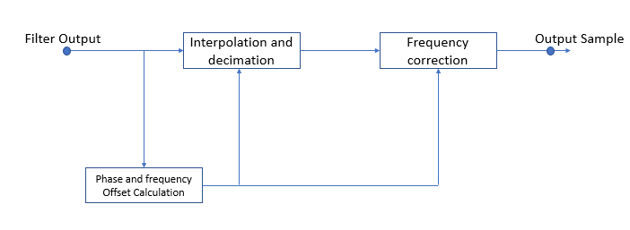
In this method, the phase and frequency offset are calculated and corrected by analyzing each sample in a non-recursive manner
Figure ‎2.4 Generic Feed Forward System
FeedBack Synchronization Method
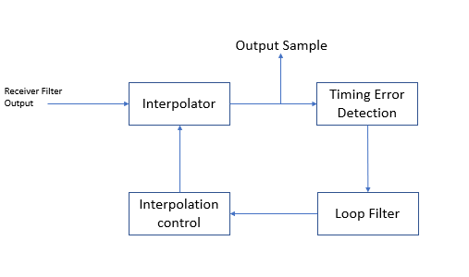
This is a more reliable and accurate time synchronization method than feed-forward synchronization. It works in a closed-loop.
Figure ‎2.5 Generic Feed Forward Timing Synchronization
In the above Fig, each block has its functionality and collectivity synchronize the system to take the sample at the optimal time instance. Detailsof each block aregiven below
Match Filter:
The mandate of the matched filter is to extract the known signal froma noisyreceived signalwith better SNR.
Interpolation:
It is the process to convert the sampled data to a higher data rate by doing upsampling along with the filters.
Timing Error Detectors:
The basic purpose of the detector is to approximate the transmitted sequences. An error signal is produced by timing error detectors once every symbol is based on the current timing estimate and using match filter input and matched filter output (Michael rice book). The basic purpose of TEDs is to estimate the timing error τ so that the receiver can adjust its timing to avoid ISI. There are several timing error detectors mainly known as
ZCTED (Zero Crossing TED)
It works on the zero crossing of the eye diagram and operates at two samples/symbols on the matched filter output.

ML-TED (Maximum likelihood TED)
In MLTED, the received symbol and timing offset is estimated together which results in complex computations. It also makes MLTED impractical to implement. Moreover, the MLTED method works for fixed timing offset but in the real world, timing offset may vary concerning time because of different clock frequencies at transmitters and receivers
Loop Filter:
A loop filter is used to correct synchronization errors. its performance is assessed by its error correction speed and how much error it can tolerate.

CHAPTER 3
Methodology
In high data processing networks, time synchronization can be achieved with the help of application layer protocols by using the time correction feature. This leads to more processing capability devices and consumes more energy whereas IoT requires less computational and energy-efficient protocols for time synchronization.
This thesis will explore the possibility of application layer time synchronization by using the underlying physical layer having a symbol timing recovery algorithm to map the offset. This method will provide an efficient way forward for multilayer time synchronization for IoT networks.
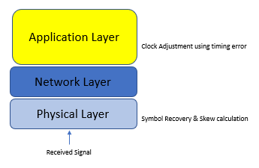
Figure ‎3.1 Clock Extraction/correction
The received signal is firstly processed by the physical layer. The physical layer consists of analog to digital converters, filters, and interpolators. Which will process the sample by using the symbol timing recovery method to extract the offset and will calculate the phase and skew offset to calculate the fractional interval. This fractional interval will be directly mapped on the application layer to adjust the clock of the top layer without any other processing at the application layer.

CHAPTER 4
Implementation
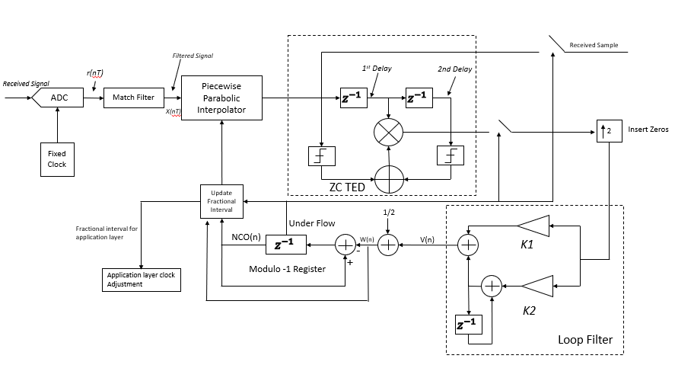
Figure ‎4.1 Block Diagram Symbol Timing Synchronization and Application layer clock adjustment using ZC TED
Model for Extraction of Clock fraction for Application Layer
Symbol timing synchronization by using ZC TED
In themodel shown in the above Fig, Symbol timing synchronization is achieved by usinga zero-crossingtiming error detection scheme. Whenthe modulated signal is received, it passes through a receiverfilter. In my thesis raised cosine filter is used for pulse shaping whoseimpulse responseisgivenbelow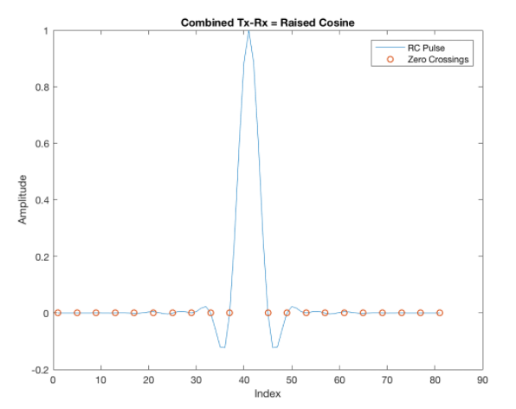
Figure ‎4.2Impulse response of cosine filter at transmitter and receiver
After the filtrationprocess, the signal is converted from analog signal (r(t)) to digital signal r(nT)where T is the sample period. This received signal issampled at a rate of 2 samples per symbol. These samples are filtered by the matched filter. The matched filter enhances the signal SNR and removesthe unwanted signal.The output of the matched filter is used bya piecewise parabolic interpolator to derive the interpolants.
These interpolants become the input for the zero-crossing timing error detector. The error signal is updated at 1 sample/symbol. The error signal is up the sample by padding zeros in it and becomes the input of the loop filter which has gains K1 and K2. The matched filter output is the input of the modulo 1 interpolator which updates the fractional interval.
This fraction interval is used by the application layer to synchronize the clock. If we minus the fraction interval from the clock from the application layer thenthe timing error can easily be removed.
MATLAB code is written to prove this concept and given in appendix A.

CHAPTER 5
Results
Timing Error correction for Binary PAM (Pulse Amplitude Modulation)

Figure ‎5.1MF & dMF Response

The above graph elaborates a comparison between the matched filter output put with the derivative matched filtered output.dMF gives the zero value where the slope is minimum. This approach is used in ML (Maximum likelihood) TED.

Figure ‎5.2Timing Error
Figure ‎5.3 PI Controller Output

Figure ‎5.4 Fractional Error
Fractional interval and timing intervalare the parametersthatkeep on changing to an optimal level where the loop filter is locked and the system synchronized.
Figure ‎5.5 Constellation Diagram BPSK
The constellation diagram gives a brief overview of the effect of interference on the signal. The following constellation diagram shows that signal is much scattered without timing synchronization.
Figure ‎5.6 Constellation diagram after recovery
By using the ZCTED, it can be observed that samples are close together which means that samples are recovered correctly.
Figure ‎5.7 Clock deviation
This graph shows the actual clock and deviated clock. The red line shows the expected synchronized clock whereas the blue shows the deviated clock. The deviated clock can easily be corrected by adding some offset which is obtained from symbol timing recovery. And same synchronized clock can be used at application layer without additional correction protocols at application layer.

Timing error correction for QAM
The timing error correction mechanism used for BPSK can be employed for QAM to get the synchronization at the application layer. Results are as under
Figure ‎5.8 Matched Filter and Derivative Matched Filter
Figure ‎5.9 Timing Error
Figure ‎5.10 PI controller Output

Figure ‎5.11 Fractional Error
Figure ‎5.12 Constellation diagram without correction
Conclusion:
Figure ‎5.13 Clock synchronization
Figure ‎5.14 Constellation diagram with correction
In most communication devices, time synchronization at the application layer is done by usinga distinct protocol thatrequires complex computation and IoT devices cannot afford such type of processing at the hardware or software level as well as interlayer communication. In this thesis, it is suggestedthat the timing offset calculated by the physical layer using the symbol timing recovery method, can be used for synchronization at the application layer. Thus, it will also reduce the packets-basedcommunication between the higher layers with underlaying layer and allow designers to make more efficient, compact, and less power-consuming devices.

References:
[1] P. Sethi and S. R. Sarangi, “Internet of Things: Architectures, Protocols, and Applications,” J. Electr. Comput. Eng., vol. 2017, 2017, doi: 10.1155/2017/9324035.
[2] Egham, “8.4 Billion Connected Things Will be in Use 2017 | Gartner,” 2017. https://www.gartner.com/en/newsroom/press-releases/2017-02-07-gartner-says-8-billion-connected-things-will-be-in-use-in-2017-up-31-percent-from-2016 (accessed Sep. 19, 2021).
[3] K. Xie, Q. Cai, and M. Fu, “A fast clock synchronization algorithm for wireless sensor networks,” Automatica, vol. 92, pp. 133–142, 2018, doi: 10.1016/j.automatica.2018.03.004.
[4] S. Elhadi, A. Marzak, N. Sael, and S. Merzouk, “Comparative Study of IoT Protocols,” SSRN Electron. J., 2018, doi: 10.2139/ssrn.3186315.
[5] M. Wazid, A. K. Das, V. B. K, and A. V Vasilakos, “LAM-CIoT: Lightweight authentication mechanism in cloud-based IoT environment,” J. Netw. Comput. Appl., p. 102496, 2019, doi: 10.1016/j.jnca.2019.102496.
[6] H. Packard, “Fundamentals_Quartz_Oscillators,” App Notes, pp. 1–28, 1997, [Online]. Available: papers://b601f53a-84e1-4f0c-abd7-620bc101dbfb/Paper/p2186.
[7] D. Djenouri and M. Bagaa, “Synchronization protocols and implementation issues in wireless sensor networks: A review,” IEEE Syst. J., vol. 10, no. 2, pp. 617–627, 2016, doi: 10.1109/JSYST.2014.2360460.
[8] M. Buevich, N. Rajagopal, and A. Rowe, “Hardware assisted clock synchronization for real-time sensor networks,” Proc. - Real-Time Syst. Symp., pp. 268–277, 2013, doi: 10.1109/RTSS.2013.34.
[9] A. Marco, R. Casas, J. Sevillano Ramos, V. Coarasa, A. Asensio, and M. Obaidat, “Synchronization of multihop wireless sensor networks at the application layer,” IEEE Wirel. Commun., vol. 18, no. 1, pp. 82–88, 2011, doi: 10.1109/MWC.2011.5714029.
[10] T. Lennvall, J. Akerberg, E. Hansen, and K. Yu, “A new wireless sensor network TDMA timing synchronization protocol,” IEEE Int. Conf. Ind. Informatics, vol. 0, pp. 606–611, 2016, doi: 10.1109/INDIN.2016.7819233.
[11] A. R. Swain and R. C. Hansdah, “A model for the classification and survey of clock synchronization protocols in WSNs,” Ad Hoc Networks, vol. 27, pp. 219–241, 2015, doi: 10.1016/j.adhoc.2014.11.021.
[12] A. Araujo et al., “Wireless measurement system for structural health monitoring with high time-synchronization accuracy,” IEEE Trans. Instrum. Meas., vol. 61, no. 3, pp. 801–810, 2012, doi: 10.1109/TIM.2011.2170889.
[13] V. Di Lecce, A. Amato, and M. Calabrese, “GPS-aided lightweight architecture to support multi-sensor data synchronization,” Conf. Rec. - IEEE Instrum. Meas. Technol. Conf., pp. 149–154, 2008, doi: 10.1109/IMTC.2008.4547021.
[14] H. Mohammadmoradi, O. Gnawali, N. Rattner, A. Terzis, and A. Szalay, “Robust time synchronization in wireless sensor networks using real time clock,” pp. 356–357, 2014, doi: 10.1145/2668332.2668365.
[15] T. Schmid, Z. Charbiwala, R. Shea, and M. B. Srivastava, “Temperature compensated time synchronization,” IEEE Embed. Syst. Lett., vol. 1, no. 2, pp. 37–41, 2009, doi: 10.1109/LES.2009.2028103.
[16] T. Qiu, X. Liu, M. Han, H. Ning, and D. O. Wu, “A Secure Time Synchronization Protocol Against Fake Timestamps for Large-Scale Internet of Things,” IEEE Internet Things J., vol. 4, no. 6, pp. 1879–1889, 2017, doi: 10.1109/JIOT.2017.2714904.
[17] J. Elson, L. Girod, and D. Estrin, “Fine-grained network time synchronization using reference broadcasts,” Oper. Syst. Rev., vol. 36, no. Special Issue, pp. 147–163, 2002, doi: 10.1145/844128.844143.
[18] S. Ganeriwal, R. Kumar, and M. B. Srivastava, “Timing-sync Protocol for Sensor Networks Categories and Subject Descriptors,” Proc. 1st Int. Conf. Embed. networked Sens. Syst. (SenSys ’03), pp. 138–149, 2003, [Online]. Available: http://citeseerx.ist.psu.edu/viewdoc/download?doi=10.1.1.58.3367&rep=rep1&type=pdf.
[19] J. He, P. Cheng, L. Shi, J. Chen, and Y. Sun, “Time synchronization in WSNs: A maximum-value-based consensus approach,” IEEE Trans. Automat. Contr., vol. 59, no. 3, pp. 660–675, 2014, doi: 10.1109/TAC.2013.2286893.
[20] M. Maróti and G. Simon, “The flooding time synchronization protocol.,” 2015.
[21] Q. M. Chaudhari and E. Serpedin, “Clock offset and skew estimation in wireless sensor networks with known deterministic delays and exponential nondeterministic delays,” Proc. - 3rd Int. Conf. Digit. Telecommun. ICDT 2008, pp. 37–40, 2008, doi: 10.1109/ICDT.2008.8.
[22] Q. M. Chaudhari, E. Serpedin, and K. Qaraqe, “Some improved and generalized estimation schemes for clock synchronization of listening nodes in wireless sensor networks,” IEEE Trans. Commun., vol. 58, no. 1, pp. 63–67, 2010, doi: 10.1109/TCOMM.2010.01.080226.
[23] F. Sivrikaya and B. Yener, “Time Synchronization‘in Sensor Networks: A Survey,” 2004.
[24] Y. C. Wu, Q. Chaudhari, and E. Serpedin, “Clock synchronization of wireless sensor networks,” IEEE Signal Process. Mag., vol. 28, no. 1, pp. 124–138, 2011, doi: 10.1109/MSP.2010.938757.
[25] O. Simeone, U. Spagnolini, Y. Bar-Ness, and S. Strogatz, “Distributed synchronization in wireless networks,” IEEE Signal Process. Mag., vol. 25, no. 5, pp. 81–97, 2008, doi: 10.1109/msp.2008.926661.
[26] Q. Ye and L. Cheng, “Time synchronization in wireless sensor networks,” Handb. Theor. Algorithmic Asp. Sensor, Ad Hoc Wireless, Peer-to-Peer Networks, pp. 403–414, 2005, doi: 10.1201/9780203323687.

